Prepared by:
GM Bong Villamayor

EVALUATION & PLANNING
“The Key To All Chess Positions”

Introduction:

Every chess player must learn how to evaluate a position. Of course evaluation or analysis depends on the level of knowledge and experience that a player has.
The demands of time in the study and understanding of many positions has been the call of many players.
Basically we know that there are three stages in a game of chess the Opening, The Middle game and The Endgame.
We also know that there are many principles that guide us on how to continue and play in the different stages of the game.
When a player evaluates a position he sees the different aspects of the position. Example: the comparison of the different pieces (with the opponents’) in respect to their positions, the structure or the placement of the pawns.
Others include the basic counting of material, position of the king and many more. Also it is very important to consider the tactical possibilities of both sides.

Because of this, our knowledge and experience creates familiar positions in which we select our moves and satisfy our objectives.
These positions we call “SCHEMES”.
The many schemes that we formulate are very much inter-related. These “little plans” constitute the basic means of Evaluation and Planning.

TABLE OF CONTENTS

- What is Evaluation or Analysis?

2. Why do we need to Evaluate/Analyze a Position?

3. When do we analyze?

4. How do we analyze?

  - Kinds of Analysis
    - Concrete
    - General

  - Basic Questions of Analysis
    - Material
    - Mobility
    - Pawn Structure
    - Tactical Possibilities
    - King Position

  - Types of Advantages
    - Permanent Advantage
    - Temporary Advantage

1. WHAT IS EVALUATION OR ANALYSIS?

Evaluation or Analysis is the sum total of the many aspects of a given chess position. It is like identifying the different functions and comparisons of the pawns and pieces.

2. WHY DO WE NEED TO EVALUATE OR ANALYSE A POSITION?

The need to know the details of a chess position will be your basis on how to formulate a plan in the middle game.

3. WHEN DO WE EVALUATE OR ANALYSE?

Normally we calculate moves over the board and we choose our
moves based upon our knowledge and experience. This knowledge and experience came from our games and the guiding rules and principles that we have learned when we knew our first steps in chess.
As a rule we must evaluate right after the opening after we have completed our development of the pieces and castled our king to safety.

4. HOW DO WE EVALUATE OR ANALYSE A POSITION?

Actually there are two kinds of analysis, namely CONCRETE and GENERAL.
Concrete analysis is when we think of moves and trying to satisfy ourselves on what we see in our calculation. This is normally done when tactics are involved. Done when it’s our move.
General analysis is when we ask ourselves what are we going to do in a position. How do we continue? If there are two to three choices of sound moves we have to find out through evaluation what is the best plan in the position. Normally done if it’s your opponent’s turn

BASIC QUESTIONS OF ANALYSIS:

- Who is ahead in Material?

- Who has the Better Piece Mobility?

- Who has the Better Pawn Structure?

- What are the Tactical Possibilities in the Position?

- Who has the Better King Position?

TYPES OF ADVANTAGES:

- Permanent Advantage –
  - Normally this is related to the Pawn Structure or Material Balance e.g. (Advantage in Material Without any Compensation, Pawn Weaknesses, Weak Squares, Exposed King, An uncontested Rank, File or Diagonal)

- Temporary Advantage-
  - This is related to the time or moves to be made to improve the position e.g. (Badly Placed Piece or Pieces, Development Advantage, A Tactical Possibility of an Attack against the King or Pieces)

EXAMPLE POSITIONS FOR EVALUATION

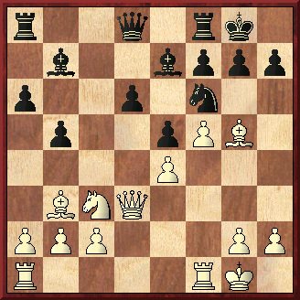
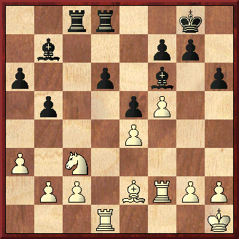

1. Bxf6 Bxf6 2. Bd5! 1… d5!
Petrosian – Smyslov
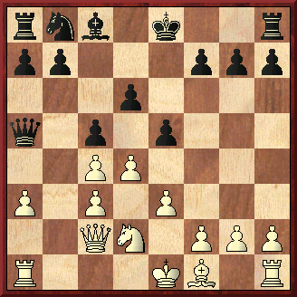
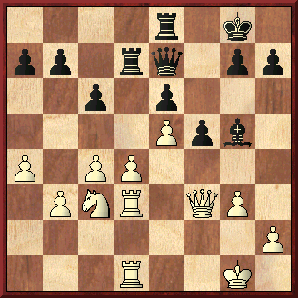
Moscow, 1949

1. dxe5! dxe5 1. c5!
Botvinnik – Kan Botvinnik - Flohr
Leningrad, 1939 Moscow, 1936

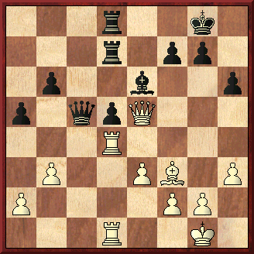
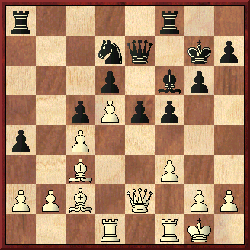

1… e4! 2. fxe4 Bxc3 3. bxc3 f4!
Pilnik – Geller Botvinnik - Zagoriansky
Gothenburg, 1955 Sverdlovsk, 1943

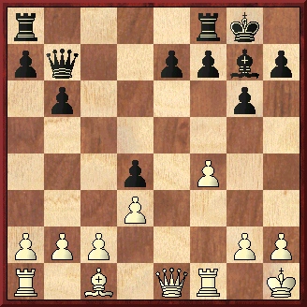
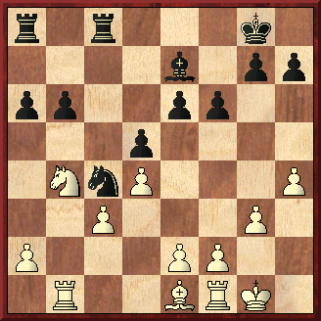

Thomas – Alekine Najdorf - Averbakh

Petrosian,T - Smyslov,V [B84]

URS-ch17 Moscow, 1949
[ChessBase]
1.e4 c5 2.Nf3 d6 3.d4 cxd4 4.Nxd4 Nf6 5.Nc3 a6 6.Be2 e6 7.0–0 Be7 8.Be3 0–0 9.f4 Qc7 10.f5 [ 10.Qe1 … £g3] 10...e5 11.Nb3 b5 12.a3 Bb7 13.Bf3 Rd8 14.Nd2 [ 14.g4 d5 15.exd5 e4 16.Nxe4 Nxd5 17.Qe2 Nd7©] 14...Nbd7 15.Kh1 Rac8 16.Qe2 Nb6 17.Qf2 Nc4 18.Nxc4 Qxc4 19.Bg5 h6 20.Bxf6 Bxf6 21.Rad1 Qc5 22.Be2 [ 22.Qxc5 Rxc5] 22...Qxf2 23.Rxf2 d5!
24.Nxd5 [ ¹24.exd5 e4 25.Nxe4 Bxb2 26.Bf3 Bxa3 27.Rd3] 24...Bxd5 25.exd5 Rxc2 26.b3 e4! …27...e3 27.g4 e3 28.Rg2 Rd2 29.Rxd2 exd2 30.Bd1 Rxd5 31.Kg1 Kf8 32.Kf1 Bg5 33.a4 h5 34.h3 h4 35.axb5 axb5 36.Rf2 Ke7 37.Rf3 Re5 38.Be2 Rd5“ [ 38...Be3 39.f6+ gxf6 40.Rf5] 39.Bd1 Kf6 40.Rc3 Bf4 41.Ke2 Kg5 42.Rf3 b4 43.Kf1 [ 43.Rd3 Re5+ 44.Kf2 Re1 45.Bf3 f6 46.Be2 Rh1] 43...Re5 44.Be2 Be3 45.Bd1 Kf6 46.Be2 Re4 [Smyslov] 0–1

Botvinnik,M - Kan,I [E24]
URS-ch11 Leningrad (10), 1939
1.d4 Nf6 2.c4 e6 3.Nc3 Bb4 4.Nf3 c5 5.a3 Bxc3+ 6.bxc3 Qa5 7.Bd2 Ne4 8.Qc2 Nxd2 9.Nxd2 d6 10.e3 e5 11.dxe5 dxe5 12.Bd3 h6 13.0–0 0–0 14.f4 Nd7 15.f5 Nf6 16.Ne4 Qd8 17.Nxf6+ Qxf6 18.Be4 Rb8 19.Rad1 b6 20.h3 Ba6 21.Bd5 b5 22.cxb5 Rxb5 23.c4 Rb6 24.Rb1 Rd8 25.Rxb6 axb6 26.e4 Bc8 27.Qa4 Bd7 28.Qa7 Be8 29.Rb1 Rd6 30.a4 Kh7 31.a5 bxa5 32.Qxa5 Ra6 33.Qxc5 Ra2 34.Qe3 Qa6 35.Rb8 Qa4 36.Kh2 Ra3 37.Qc5 Ra2 38.Ra8 Qxa8 39.Bxa8 Rxa8 40.Qxe5 Bc6 41.Qc7 1–0

Botvinnik,M - Flohr,S [B05]
Moscow Moscow, 1936
1.e4 Nf6 2.e5 Nd5 3.d4 d6 4.Nf3 Bg4 5.Be2 c6 6.0–0 dxe5 7.Nxe5 Bxe2 8.Qxe2 Nd7 9.f4 e6 10.c4 N5b6 11.Be3 Be7 12.Nc3 0–0 13.Rf3 Qe8 14.Rd1 Rd8 15.b3 f5 16.Nd3 Bf6 17.Bf2 Qf7 18.Ne1 Rfe8 19.Rfd3 Nf8 20.Nf3 Qc7 21.Ne5 Nbd7 22.Qd2 Be7 23.Nf3 Nf6 24.Qc1 Ne4 25.Ne5 Nxf2 26.Kxf2 Nd7 27.Qe3 Nxe5 28.fxe5 Qa5 29.a4 Rd7 30.g3 Qd8 31.Kg2 Bg5 32.Qf3 Qe7 33.c5 a5 34.Nb1 Qf8 35.Na3 Bd8 36.Nc4 Bc7 37.Nd6 Rb8 38.Rb1 Qd8 39.b4 axb4 40.Rxb4 Bxd6 41.exd6 Qa5 42.Rdb3 Re8 43.Qe2 Qa8 44.Re3 Kf7 45.Qc4 b5 46.Qc2 Rxd6 47.cxd6 c5+ 48.Kh3 cxb4 49.Qc7+ Kg8 50.d7 Rf8 51.Qd6 h6 52.Qxe6+ Kh7 53.Qe8 b3 54.Qxa8 Rxa8 55.axb5 Rd8 56.Rxb3 Rxd7 57.b6 Rb7 58.Kg2 Kg6 59.Kf3 Kf6 60.Rb5 Ke6 61.Ke3 Kd6 62.Kd3 Kc6 63.Kc4 Kd6 64.Rd5+ Kc6 65.Rc5+ Kd6 66.Kb5 1–0

Botvinnik,M - Zagoriansky,E [A13]
Sverdlovsk Sverdlovsk (6), 1943
1.Nf3 d5 2.c4 e6 3.b3 Nf6 4.Bb2 Be7 5.e3 0–0 6.Nc3 c5 7.cxd5 Nxd5 8.Nxd5 exd5 9.d4 cxd4 10.Qxd4 Bf6 11.Qd2 Nc6 12.Be2 Be6 13.0–0 Bxb2 14.Qxb2 Qa5 15.Rfd1 Rad8 16.Rd2 Rd7 17.Rad1 Rfd8 18.h3 h6 19.Ne5 Nxe5 20.Qxe5 Qc5 21.Bf3 b6 22.Qb2 Rc8 23.Qe5 Rcd8 24.Rd4 a5 25.g4 Qc6 26.g5 hxg5 27.Qxg5 f6 28.Qg6 Bf7 29.Qg3 f5 30.Qg5 Qe6 31.Kh1 Qe5 32.Rg1 Rf8 33.Qh6 Rb8 34.Rh4 Kf8 35.Qh8+ Bg8 36.Rf4 Rbb7 37.Rg5 Rf7 38.Qh5 Qa1+ 39.Kg2 g6 40.Qxg6 Bh7 41.Qd6+ Rfe7 42.Qd8+ 1–0

Pilnik,H - Geller,E [B59]
Gothenburg Interzonal Gothenburg (15), 1955
1.e4 c5 2.Nf3 Nc6 3.d4 cxd4 4.Nxd4 Nf6 5.Nc3 d6 6.Be2 e5 7.Nb3 Be7 8.0–0 0–0 9.Be3 Be6 10.Bf3 a5 11.Nd5 Bxd5 12.exd5 Nb8 13.c4 Na6 14.Bd2 b6 15.Bc3 Nc5 16.Nxc5 bxc5 17.Qe1 Nd7 18.Bd1 a4 19.Bc2 f5 20.Rd1 g6 21.Qe2 Bf6 22.f3 e4 23.Bxf6 Qxf6 24.fxe4 f4 25.Rf2 Ne5 26.Rdf1 Qh4 27.Bd1 Rf7 28.Qc2 g5 29.Qc3 Raf8 30.h3 h5 31.Be2 g4 32.Rxf4 Rxf4 33.Rxf4 Rxf4 34.g3 Nf3+ 35.Kf2 Qxh3 36.gxf4 g3+ 37.Kxf3 g2+ 38.Kf2 Qh2 0–1

Thomas,G - Alekhine,A [B02]
Baden-Baden Baden-Baden, 1925
[ChessBase]
1.e4 Nf6 2.d3 c5 3.f4 Nc6 4.Nf3 [ 4.c3?! d5 5.e5 Nd7 6.Nd2 e6 7.Ndf3 Qb6 8.Be2 f6! 9.exf6 Nxf6 10.Nh3 Bd6 11.0–0 Bd7 12.Kh1 0–0–0µ Wolf-Becker, FRG 1923] 4...g6 5.Be2 Bg7 6.Nbd2?! [ 6.c4!? × d5 … =] 6...d5 7.0–0 0–0 8.Kh1 b6³ 9.exd5 Qxd5 [ 9...Nxd5 10.Ne4 ”] 10.Qe1 [ 10.Ne5 Nxe5 11.fxe5 Qxe5 12.Nc4 ( 12.Bf3 Rb8 13.Nc4 Qc7) 12...Qe6 13.Bf3 Nd5µ] 10...Bb7 11.Nc4 Nd4 12.Ne3 Qc6 13.Bd1 Nd5! 14.Nxd4 [ 14.Nxd5 Qxd5 15.Qxe7 Rfe8 16.Qg5 Nxf3 17.Bxf3 Qxg5 18.fxg5 Bxf3 19.gxf3 Re2µ] 14...cxd4 15.Nxd5 Qxd5 16.Bf3 Qd7 17.Bxb7 Qxb7 × c2 18.c4 dxc3! 19.bxc3 Rac8 20.Bb2 Rfd8 21.Rf3 Bf6 22.d4µ × c3, c4, d5 [ 22.Qd2 Qc6 23.Rc1 Qa4 24.Ba1 Rd5µ 25.c4? Rxc4] 22...Qd5 23.Qe3 Qb5! 24.Qd2 Rd5 25.h3 e6 26.Re1 Qa4 27.Ra1 b5 28.Qd1 Rc4 29.Qb3 Rd6 30.Kh2 Ra6 31.Rff1 Be7 32.Kh1 Rcc6 33.Rfe1 Bh4! [ 33...Bd6? 34.Rxe6! fxe6 35.Qxe6+ Kg7? 36.d5! … c3-c4 ‚] 34.Rf1 [ 34.Re2 Qxb3! 35.axb3 Rxa1+ 36.Bxa1 Ra6 37.Bb2 Ra2 38.b4 ( 38.Kh2 a5!µ) 38...Bg3 39.d5 Bxf4–+ ( 39...exd5 40.c4„) ] 34...Qc4 … ¦aa4, ¦ca6 35.Qxc4 Rxc4 36.a3 Be7 37.Rfb1 Bd6! 38.g3 Kf8 39.Kg2 Ke7 40.Kf2 Kd7 41.Ke2 Kc6 42.Ra2 Rca4 43.Rba1 Kd5 44.Kd3 R6a5 45.Bc1 a6 46.Bb2 h5! 47.h4 f6 48.Bc1 e5 49.fxe5 fxe5 50.Bb2 [ 50.dxe5 Bxe5 51.Bf4 ( 51.Rg2 Rg4–+) 51...Bxf4 52.gxf4 Ke6!–+] 50...exd4 51.cxd4 b4 52.axb4 Rxa2 53.bxa5 Rxb2 0–1

Najdorf,M - Averbakh,Y [E18]
Candidats Tournament Zuerich (22), 10.10.1953
1.c4 Nf6 2.Nf3 e6 3.g3 b6 4.Bg2 Bb7 5.0–0 Be7 6.d4 0–0 7.Nc3 Ne4 8.Qc2 Nxc3 9.bxc3 Nc6 10.Ne5 Na5 11.Bxb7 Nxb7 12.Qa4 d6 13.Nd3 Na5 14.c5 Qe8 15.Qxe8 Rfxe8 16.Rb1 Rec8 17.h4 d5 18.Bf4 f6 19.Nb4 a6 20.cxb6 cxb6 21.Bd2 Nc4 22.Be1 Bxb4 23.cxb4 Na3 24.Rb3 Nb5 25.e3 Rc2 26.a4 Nd6 27.a5 b5 28.Rc3 Rc8 29.Rxc8+ Nxc8 30.f3 Ne7 31.Bf2 Kf7 32.Rb1 Nf5 33.Kf1 Nd6 34.Rb3 Nc4 35.Kg2 f5 36.Rb1 Nxe3+ 37.Kg1 f4 38.gxf4 Nf5 39.Kf1 g6 40.Rb3 Ke7 41.Rb1 Kd7 0–1

